**A Practical Training-I Report on**

**GREEN NURSERY**

*Submitted in fulfillment of the requirement of the degree of*

Bachelor of Technology

Degree in

**COMPUTER SCIENCE ENGINEERING**

*By*

**AATISH**

CSE-16\002



**Department of Computer Science Engineering**

**Satyug Darshan Institute of Engineering &Technology**

**Bhopani, Faridabad, Haryana, India**

**MAHARISHI DAYANAND UNIVERSITY, ROHTAK**

**DEC, 2018**

**TABLE OF CONTENTS**

**<**Font Style Times New Roman, size -16 Bold>

Acknowledgement i

Table of Contents ii

List of Tables iii

List of Figures iv

List of Abbreviations v

Contents Page No.

1.Introduction

1.1 Introduction to Project

1.2 Problem Statement

1.3 Objective of the Project

1.4 Methodology

1.5 Hardware and Software Requirements

2. System Design and Development.

2.1. Project details

2.2. Programming concepts used

2.3. Algorithms

2.4. Diagrams(use-case,er diagram and class diagram)(If applicable)

2.5. Flowcharts

2.6. Screen shots of developed program / software(output of your program)

2.7. Testcases

3. Conclusion

4. Scope for future work

5. References

**ACKNOWLEDGEMENT**

I have taken efforts in this project. However, it would not have been possible without the kind support and help of many individuals and organizations. I would like to extend my sincere thanks to all of them.

I am highly indebted (to SDIET) for their guidance and constant supervision as well as for providing necessary information regarding the project & also for their support in completing the project.

I would like to express my gratitude towards my parents & member (of SDIET) for their kind co-operation and encouragement which help me in completion of this project.

I would like to express my special gratitude and thanks to W3SCHOOLS and Geeksforgeeks for giving me such attention and help.

My thanks and appreciations also go to my colleague in developing the project and people who have willingly helped me out with their abilities.

**Introduction**

**1.1 Introduction to Project**

The purpose of this document is to write the functional and non functional user or coder requirements that represent the characteristics of website making on an organization. Here in our case we are making a website on **GREEN NURSERY.**

The scope and limitation of this website is:

* The Green Nursery website is developed for Business Purpose.
* Hold all details and operation related to Green Nursery and its Staff.
* Designed with Enquiry Form also.
* Allow the customers to contact with nursery staff easily.
* Verify simplicity, authority and ease of access.

**1.2 Problem Statement**

The whole process of distributing products and serving customers was done manually till date. Processing with paper i.e. checking and distributing respective products used to take time when there was no website. Customers of distant places can’t be in contact with nursery for long time.

**Disadvantage:**

* The current way of doing job is very time consuming.
* It is very difficult to analyze the customers manually.
* To take a plant one needs to come to visit nursery and then buy it, so it takes time of customer and staff also.
* All the customers can’t be handled with Nursery staff.
* The chance of losing papers are more in current system as compared to proposed system.
* Product processing take more time as it is done manually.

**1.3 Objective of the Project**

* This project has chosen to provide platform on which customer and nursery staff come together. Staff here has role to serve customers, make services in time, view all customer requests, add or remove plants form the website. And the customers on it give their precious reviews with in time interval & they can contact to nursery staff also.
* By using this website, it reduces a lot of time of staff to process overall tasks such as serving and dealing with customers, shipment of their products, etc.
* Serving the customers in minimum time and with more friendly manner is the main motive of this website.

**1.4 Methodology**

* Add Services
* Delete Services
* Update Services
* Add Products
* Delete Products
* Update Products
* View customer enquiries
* View Complete Detail of Nursery
* View Number of Services

**1.5 Hardware and Software Required**

* Web Browser
* Internet Connection

**2. System Design and Development**

**2.1 Project details**

The Green Nursery website is created to serve the customers with more reliable manner

* Searching the HTML page
* Exploring the website
* Sending the enquiry if needed

**Searching the HTML page -**

Firstly, you have to open the laptop and then search for ‘Green Nursery’ HTML page.

Other way to open page is to go to the webpage folder where it is stored. To do this, you have to open THIS PC and then go to NEW VOLUME (E:) and then open the folder named PINKU and then open the folder named PROJECT. In it open the WEBPAGE folder and then look for GREEN NURSERY webpage and then open it.

**EXPLORING THE WEBSITE -**

When you opened the website, you are on the HOME page.

Here, you can look for various options such as ABOUT US, CONTACT US, CATEGORIES and many more.

In the categories you will find various services provided by Green Nursery.

Here you can look for the Plants you want to buy and you can also contact to the nursery stall to deliver it to you.

Have a look on the plant category-

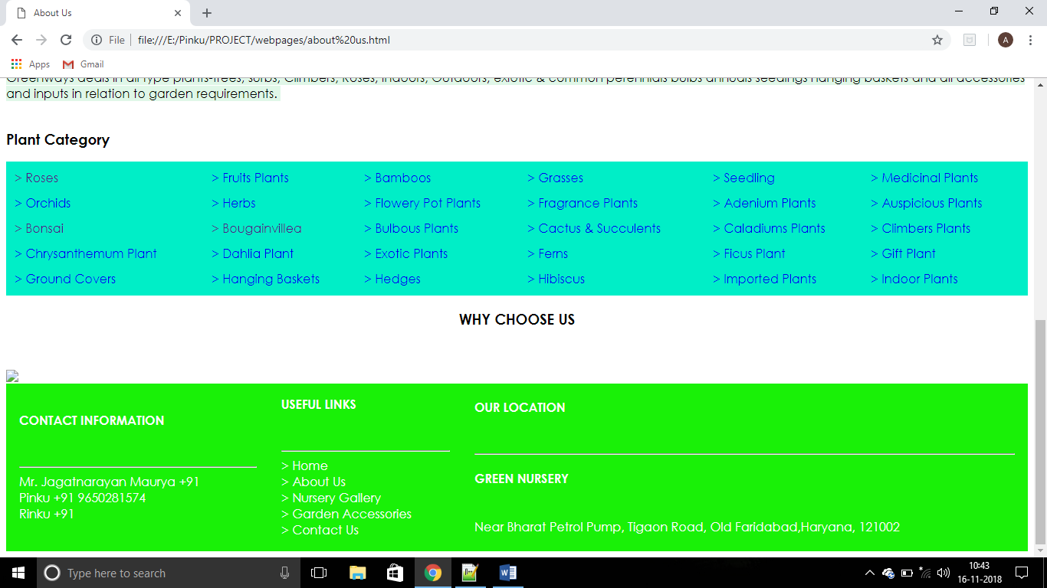

There are various categories. You can click on the kind of plant you want to buy and then a next page related to that category will show up and then you can choose from it.

Now we will talk about navigation bar.

In the navigation bar we have six options:

* ABOUT US
* NURSERY GALLERY
* LANDSCAPE-
* GARDEN ACCESSORIES
* CONTACT US

HOME is the home page of our website.

ABOUT US page gives the full details about the nursery staff and nursery properties.

On the NURSERY GALLERY page, we will have a gallery related to nursery, its landscape and also plants that it provides to its customers.

LANDSCAPE page gives the full detail about the nursery landscape and its size.

GARDEN ACCESSORIES give the details about the garden related products.

CONTACT US page gives us information about how to connect with nursery. It also have a Enquiry Form in which we can fill the required details and contact with nursery staff.

In the top of the page we have the contact number and the e-mail address by which we can connect with the nursery.

In the bottom of the page we have a column of CONTACT INFORMATION in which we have various staff contact numbers.

Then we have a column of USEFUL LINKS in which we have many options by help of which we can browse menu.

And then we have a column of OUR LOCATION in which we have the permanent location of the nursery.

**2.2 Programming concepts used**

* Hyperlinks
* Tables
* CSS
* Form

**Hyperlinks:**

**The <a> tag defines a hyperlink, which is used to link from one page to another.**

**The most important attribute of the <a> element is the href attribute, which indicates the link’s destination.**

**By default, links will appear as follows in all browsers:**

* An unvisited link is underlined and blue.
* A visited link is underlined and purple.
* An active link is underlined and red.

Links can be styled with any CSS property (e.g. color, font-family, background, etc.)

In addition, links can be styled differently depending on what state they are in.

The four link states are:

* a:link – a normal, unvisited link
* a:visited – a link the user has visited
* a:hover – a link when the user mouses over it
* a:active – a link the moment it is clicked.

**Tables:**

An HTML table is defined with <table> tag.

Each table row is defined with <tr> tag.

Each table header is defined by <th> tag.

By default, table headings are bold and centered. A table data/cell is defined with the <td> tag.

The <td> elements are the data containers of the table.

They can contain all sorts of HTML elements, text, images, lists, other tables, etc.

* Use the HTML <caption> element to define a table caption.
* Use the CSS border property to define a border.
* Use the CSS border-collapse property to collapse cell borders.
* Use the CSS padding property to add padding to cells.
* Use the CSS text-align property to align cell text.
* Use the CSS border-spacing property to set the spacing between cells.
* Use the colspan attribute to make cell span my columns.
* Use the rowspan attribute to make a cell span many rows.
* Use the id attribute to uniquely define one table.

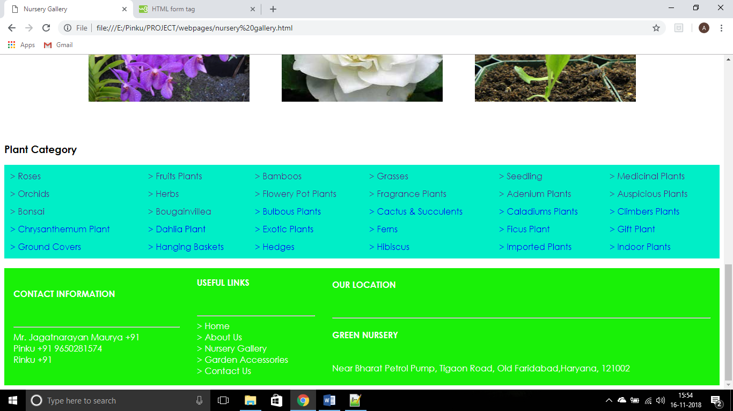

**CSS:**

When a browser reads a style sheet, it will format the HTML document according to the information in the style sheet.

Three ways to insert CSS –

* External style sheet
* Internal style sheet
* Inline style sheet

EXTERNAL STYLE SHEET

With an external style sheet, you can change the look of an entire website by changing just one file.

Each page must include a reference to the external style sheet file inside the <link> element. The <link> element goes inside the <head> section.

INTERNAL STYLE SHEET

An internal style sheet may be used if one single page has unique style.

Internal styles are defined within the <style> element, inside the <head> section of an HTML page.

INLINE STYLE

An inline style may be used to apply a unique style for a single element.

To use inline styles, add the style attribute to the relevant element. The style attribute can contain any CSS property.

Cascading Order:

All the style in a page will “cascade” into a new “virtual” style sheet by the following rules, where number one has the highest priority.

* Inline style (inside an HTML element)
* External and internal style sheets (in the head section)
* Browser default

So, an inline style has the highest priority, and will override external and internal styles and browser defaults.

Multiple Style Sheets

If some properties have been defined for the same selector (element) in different style sheets, the value from the last read style sheet will be used.

**FORM**

The <form> tag is used to create an HTML form for user input.

The <form> element can contain one or more of the following form elements:

* <input>
* <textarea>
* <button>
* <select>
* <option>
* <optgroup>
* <fieldset>
* <label>

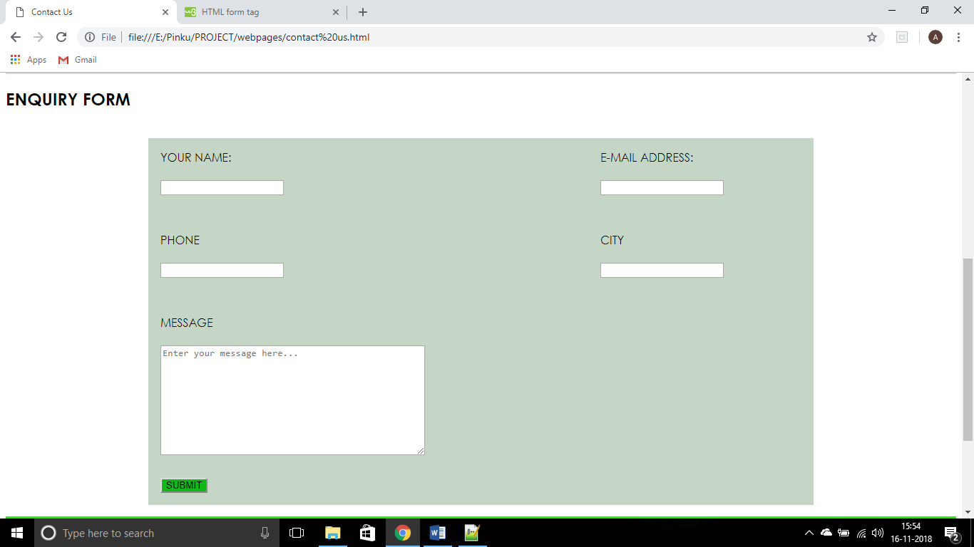

**2.3 Algorithm**

* Open the website

Firstly, you have to open the laptop and then search for ‘Green Nursery’ HTML page.

Other way to open page is to go to the webpage folder where it is stored. To do this, you have to open THIS PC and then go to NEW VOLUME (E:) and then open the folder named PINKU and then open the folder named PROJECT. In it open the WEBPAGE folder and then look for GREEN NURSERY webpage and then open it.

* Search the website

When you opened the website, you are on the HOME page.

Here, you can look for various options such as ABOUT US, CONTACT US, CATEGORIES and many more.

In the categories you will find various services provided by Green Nursery.

Here you can look for the Plants you want to buy and you can also contact to the nursery stall to deliver it to you.

* Buy the Product

Fill the enquiry form and contact with the nursery person or buy the product directly by visiting the nursery physically.

* Get it home shipped.

You can also ask for home delivery.

**2.6. Screen shots of developed program (output of your program)**

**Home page**

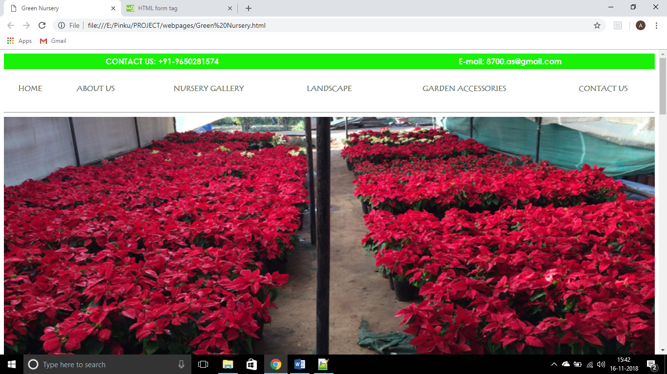

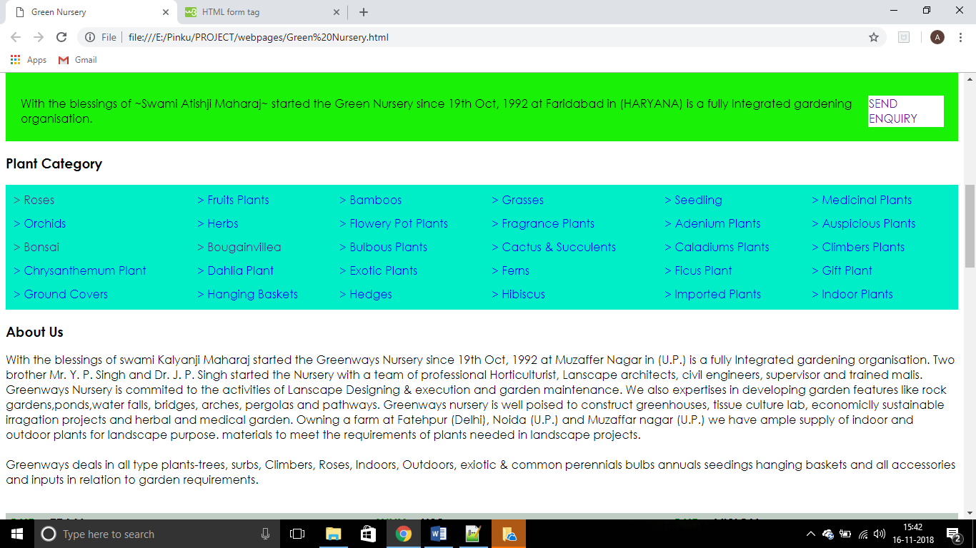

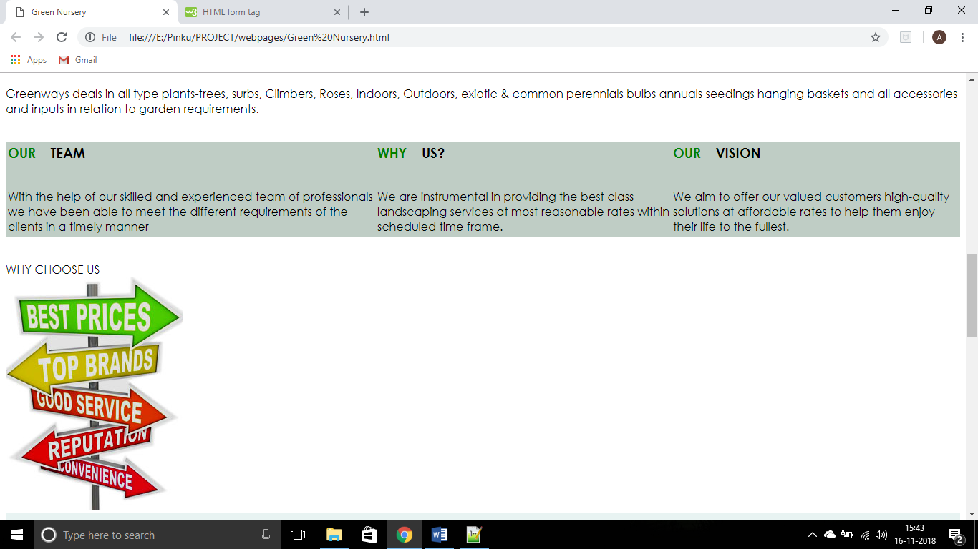

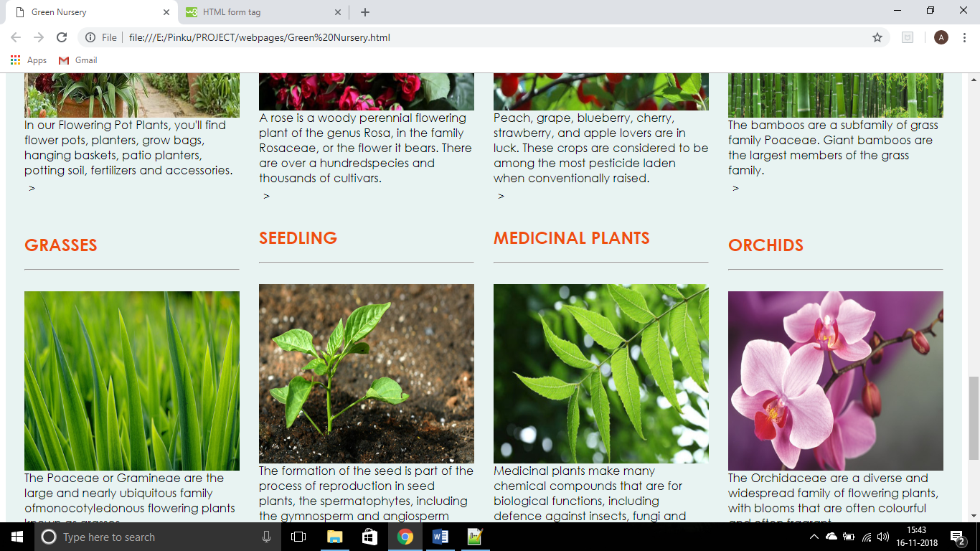

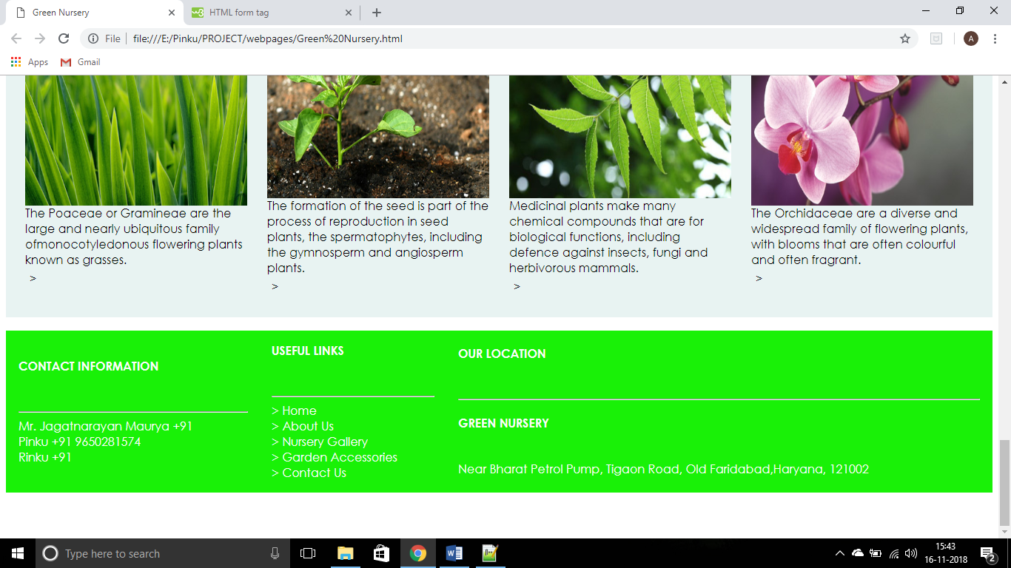

**About us page**

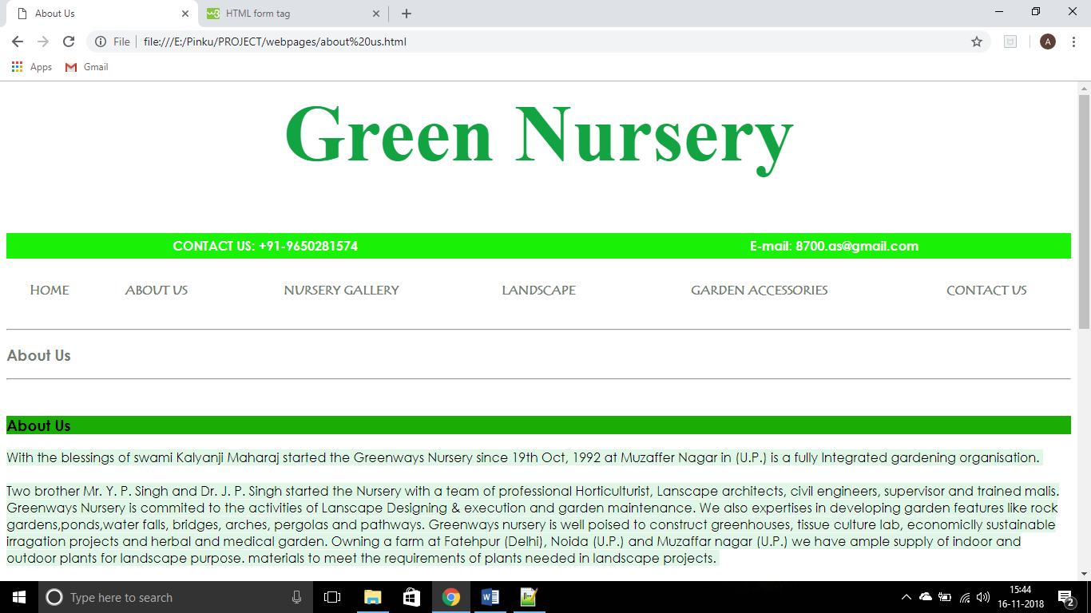

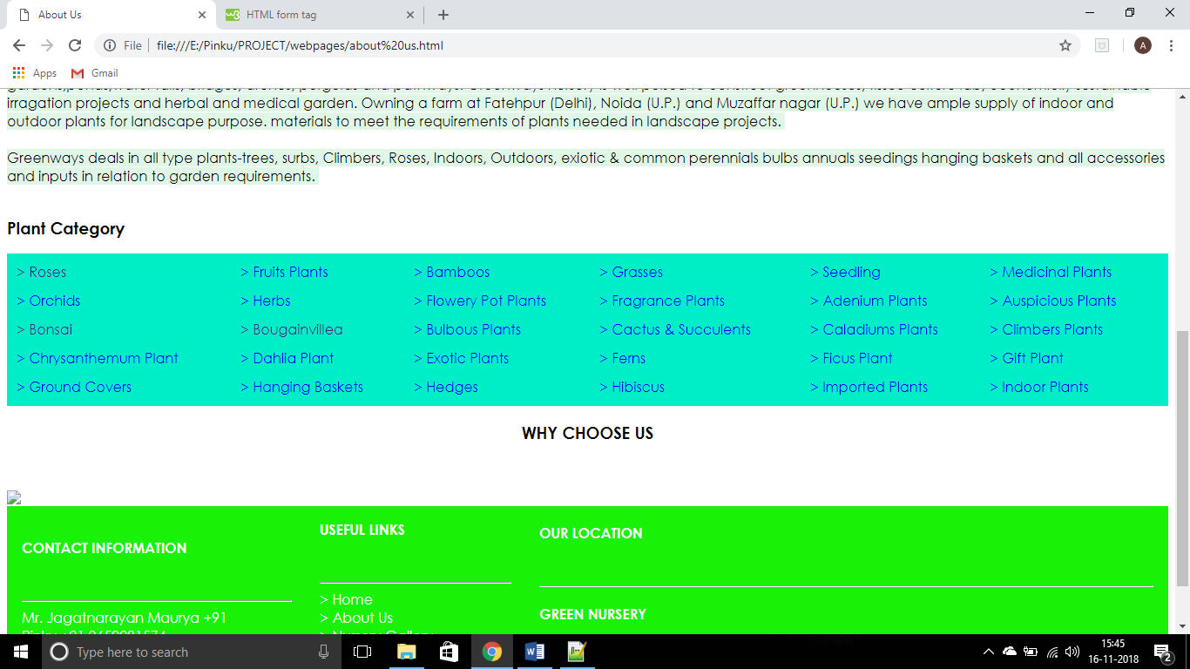

**Nursery gallery page**

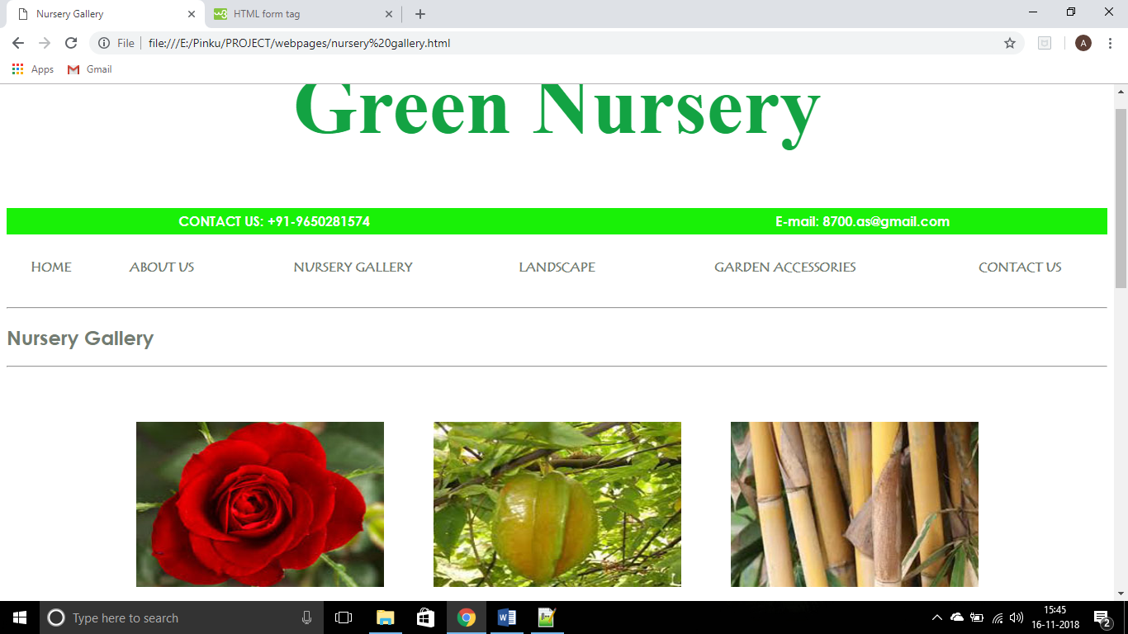

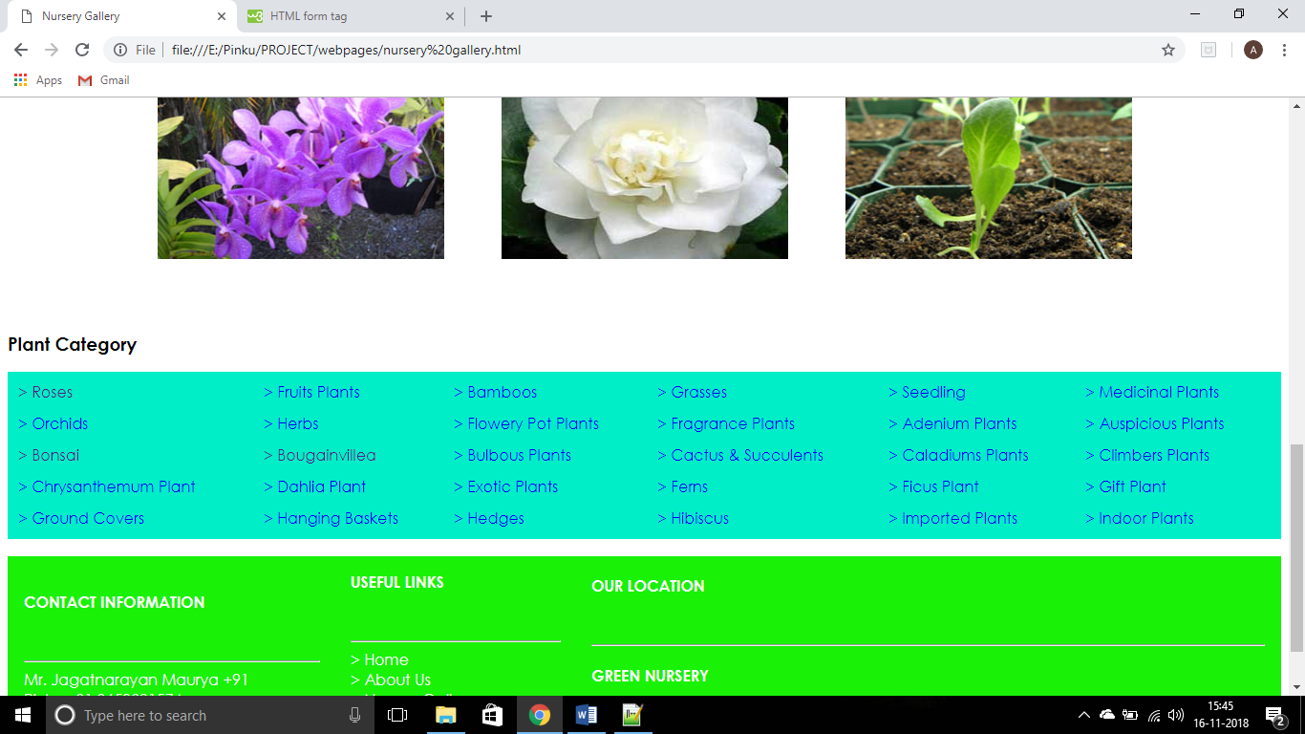

**LANDSCAPE PAGE**

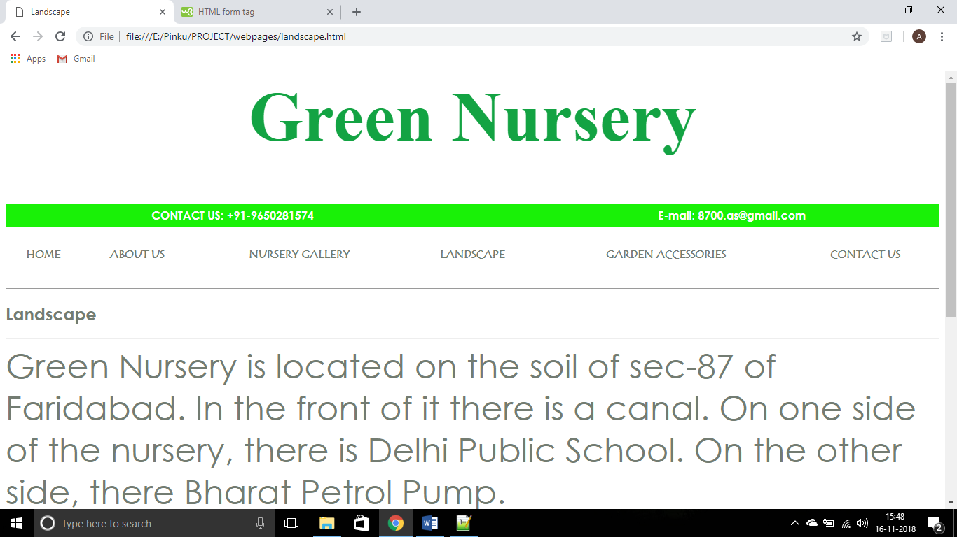

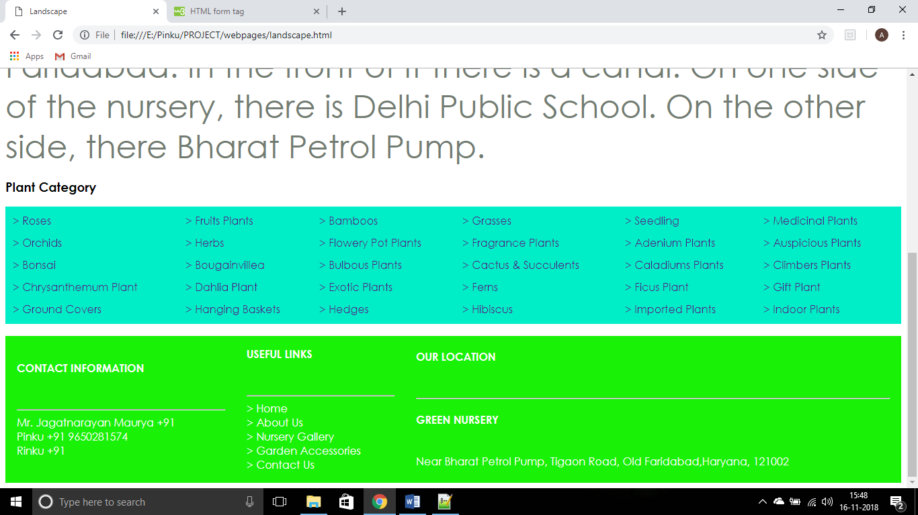

**GARDEN ACCESSORIES**

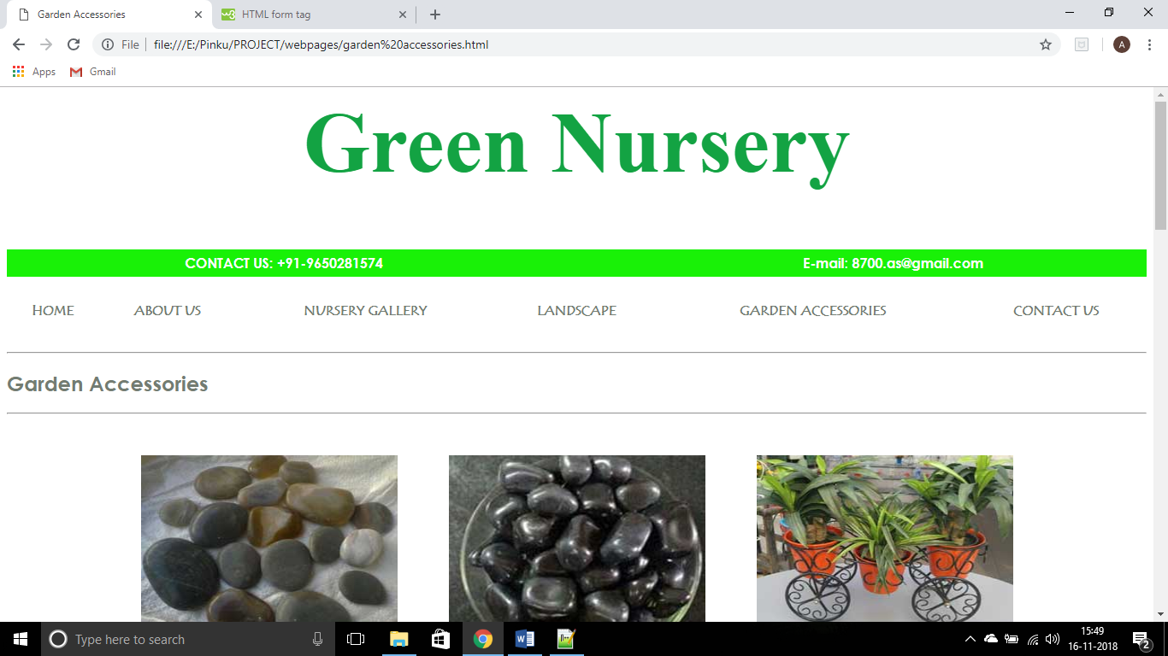

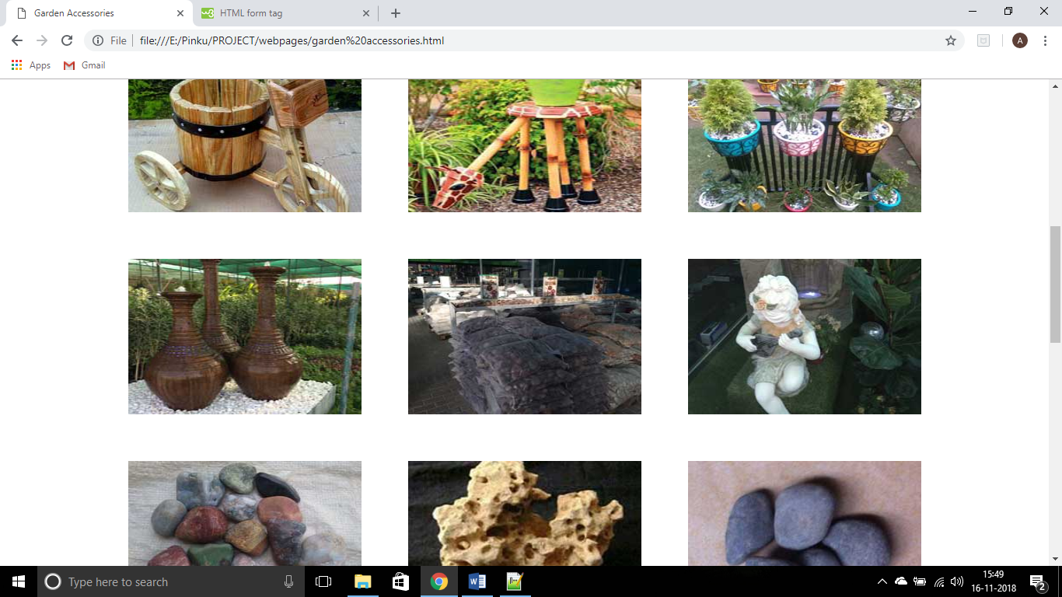

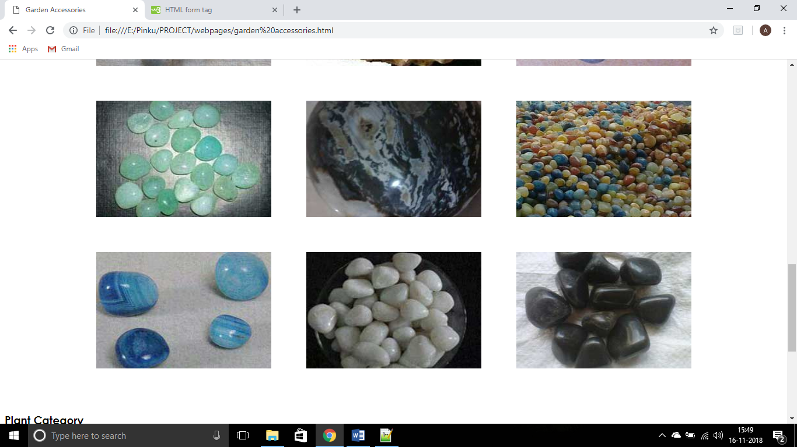

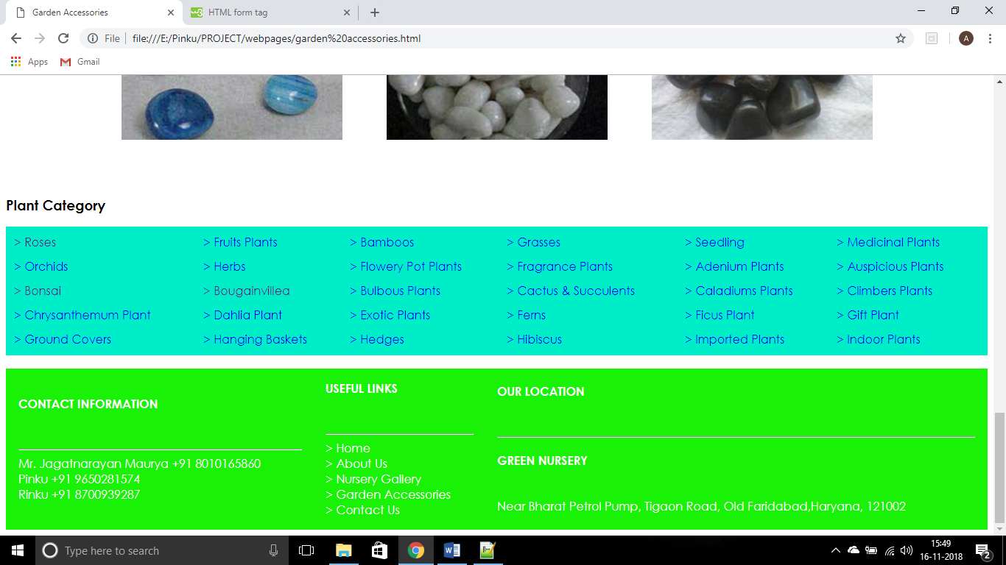

**CONTACT US PAGE**

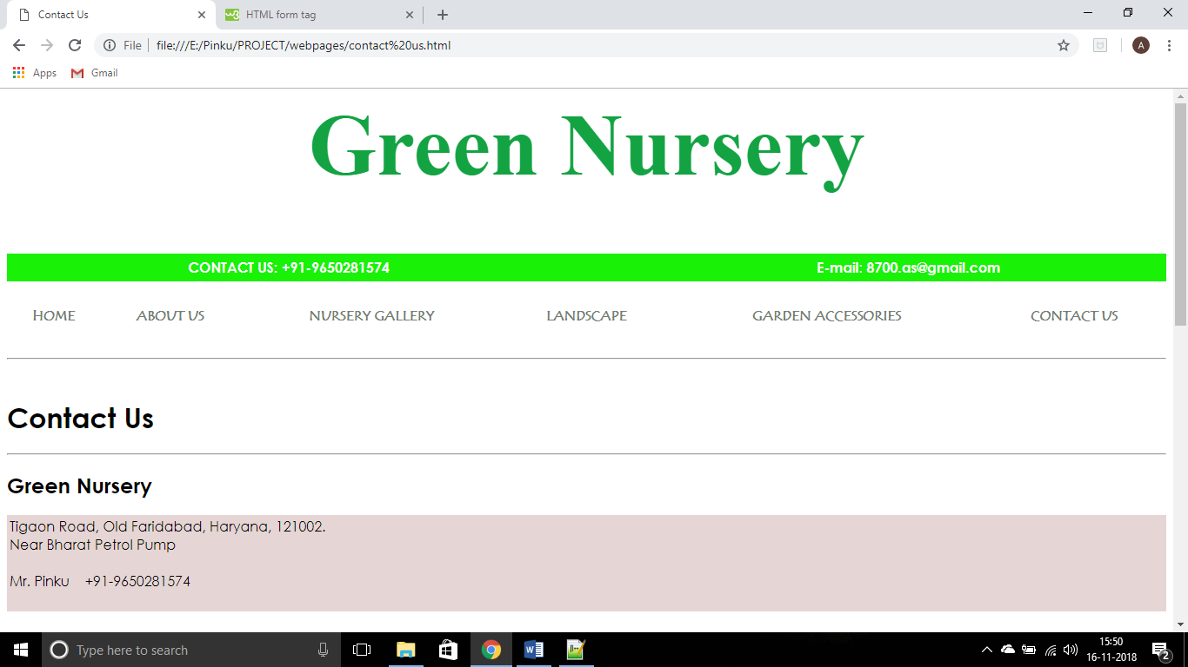

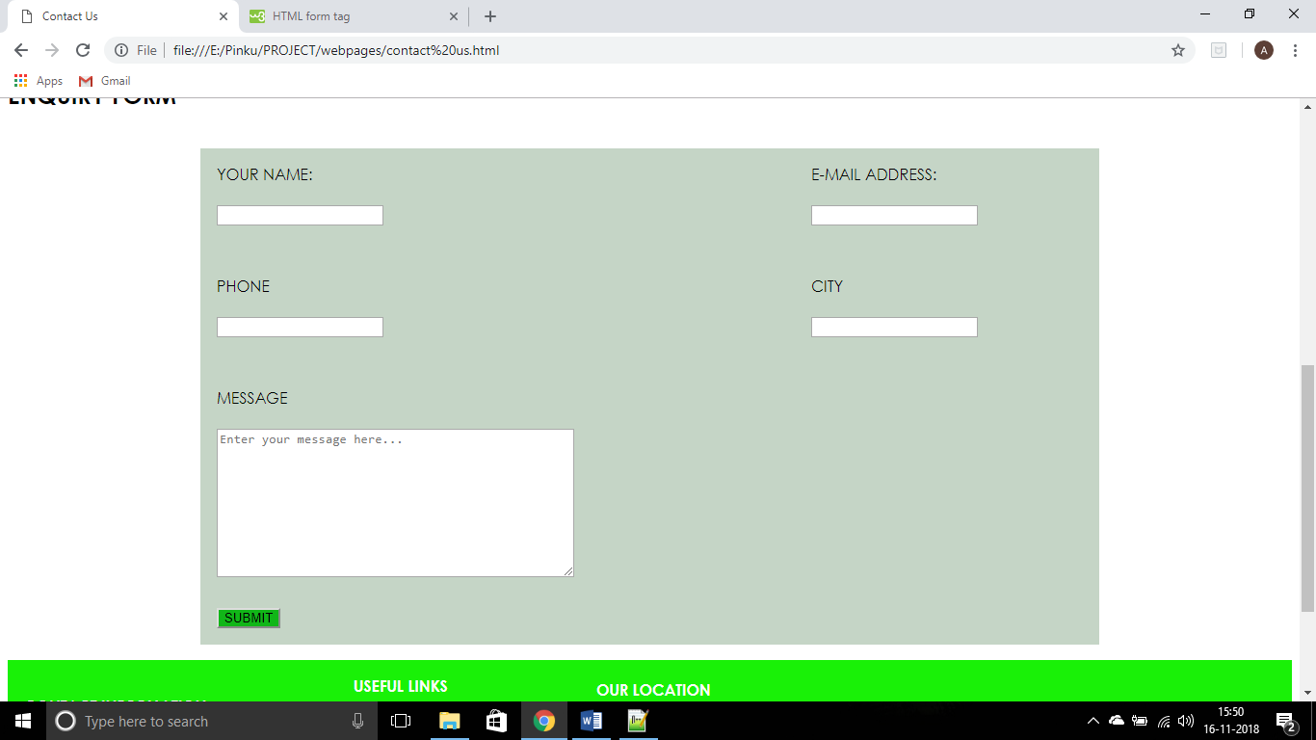

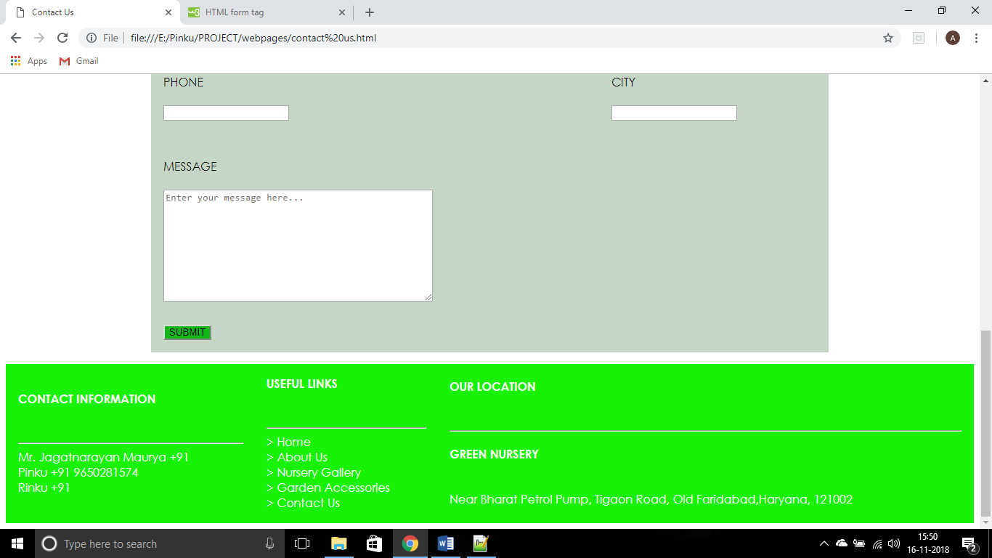

**PLANT CATEGORY LINKS**

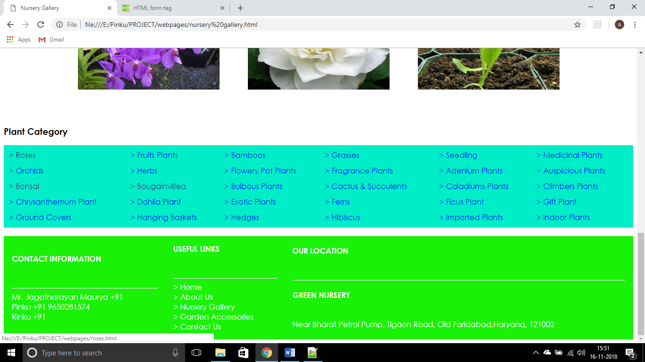

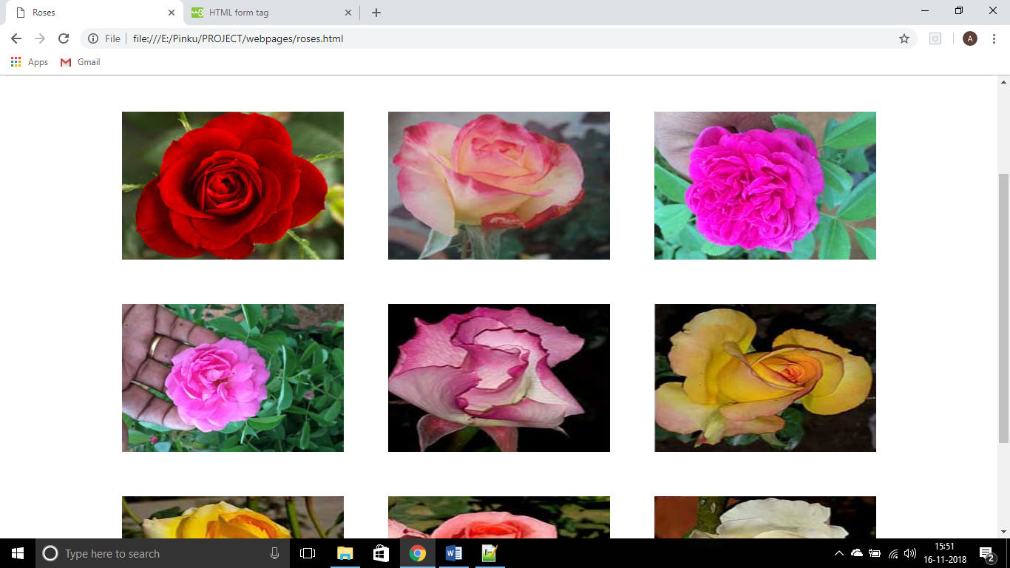

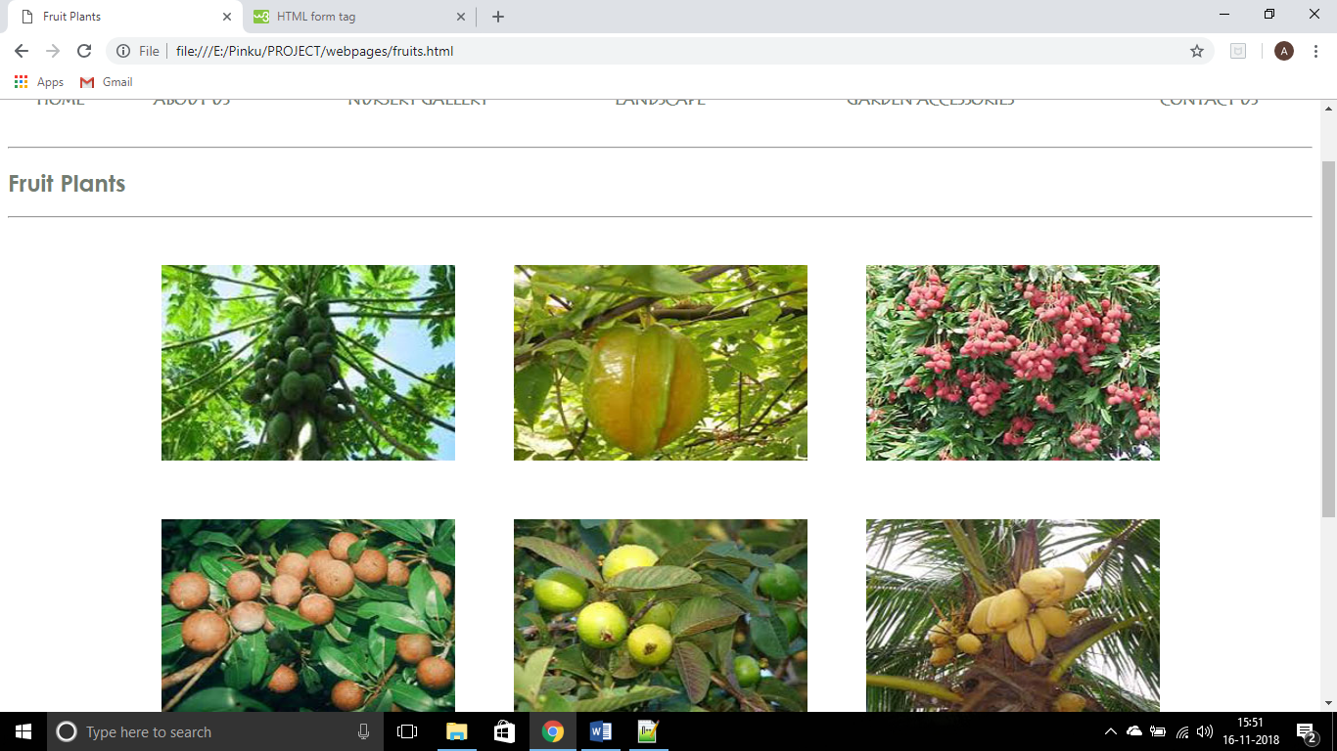

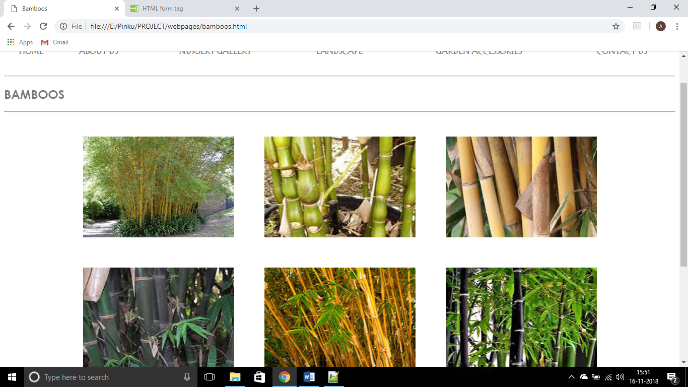

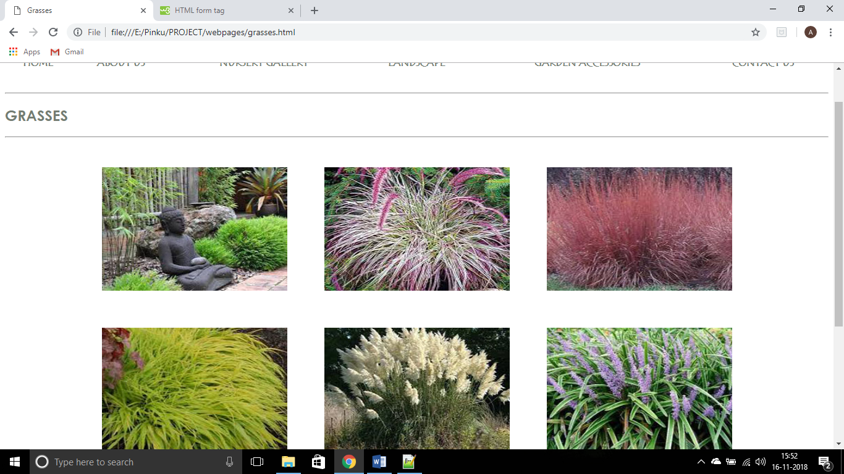

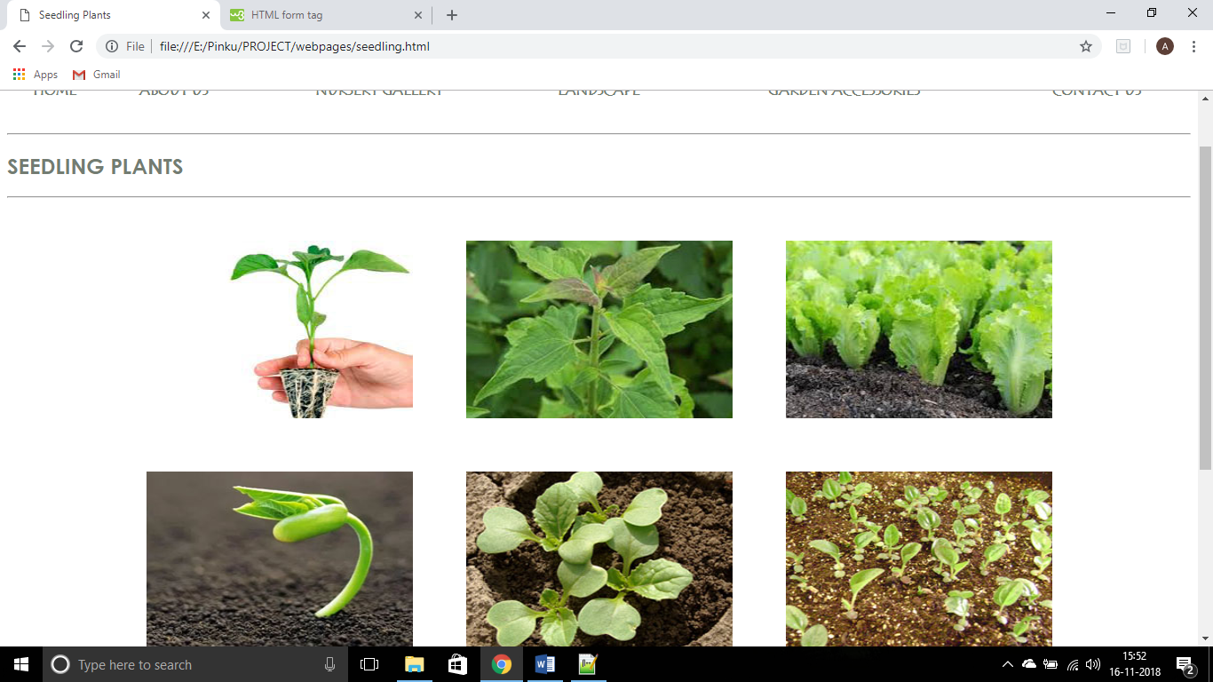

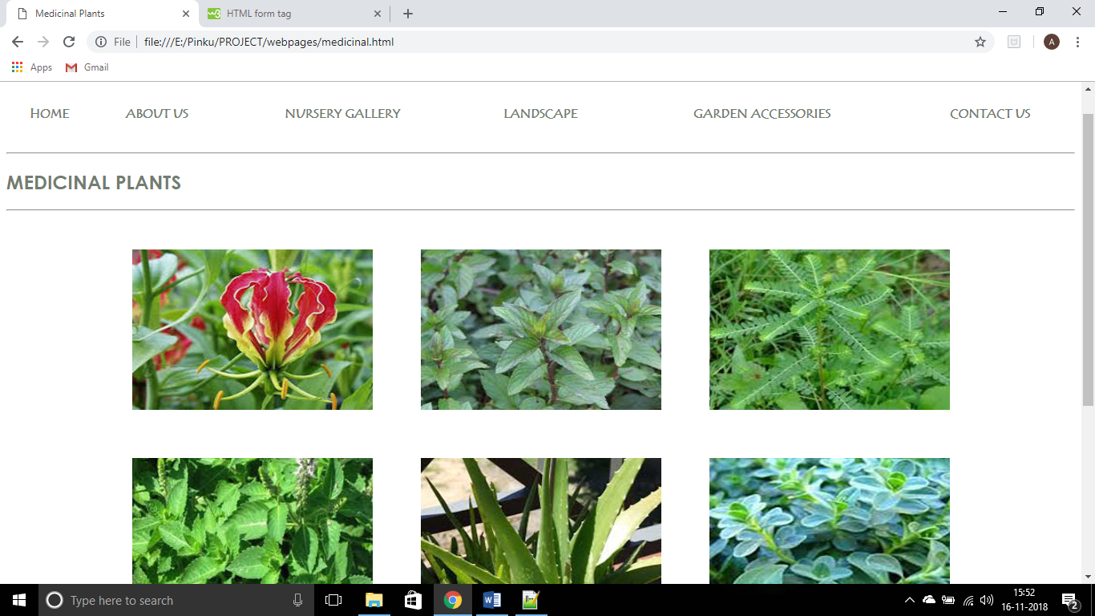

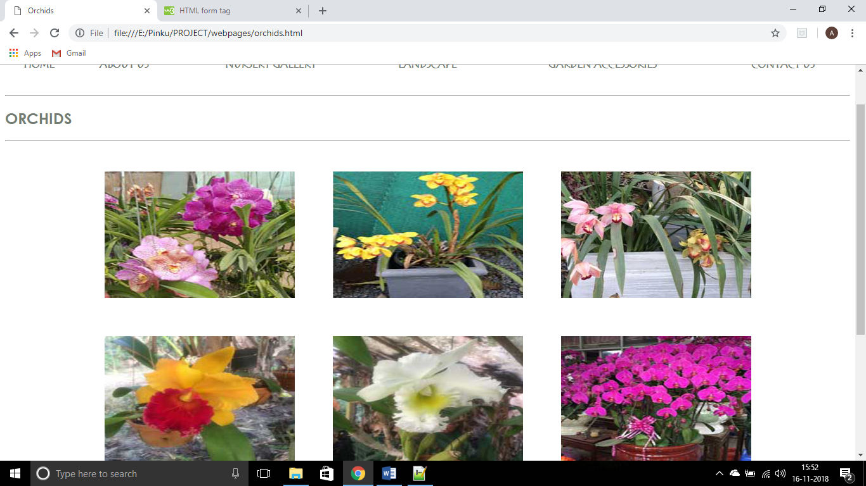

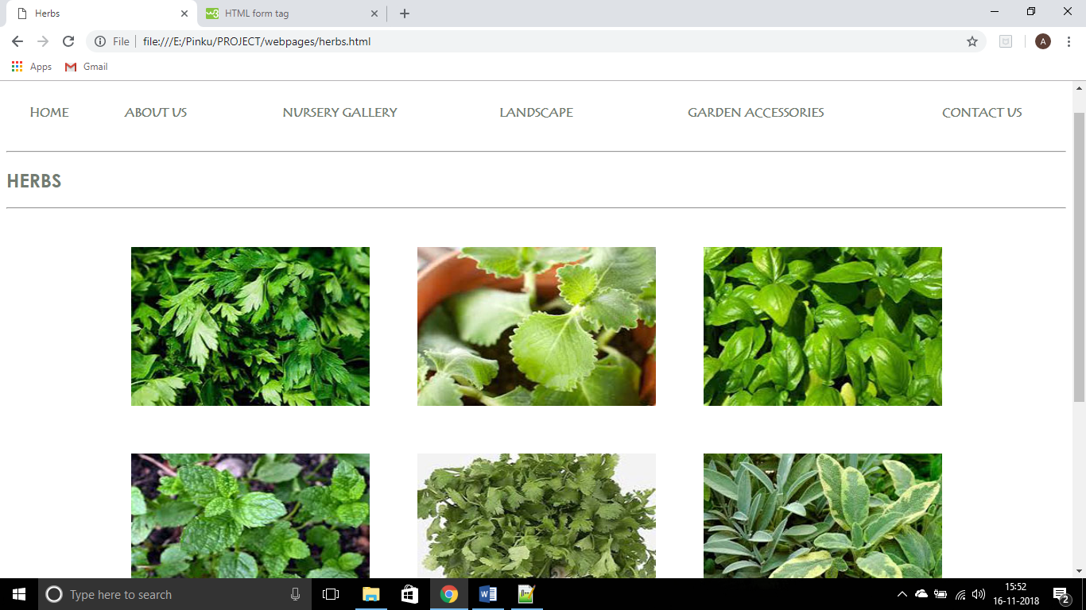

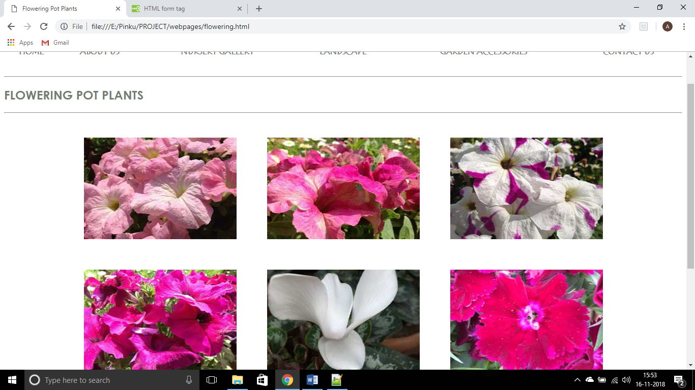

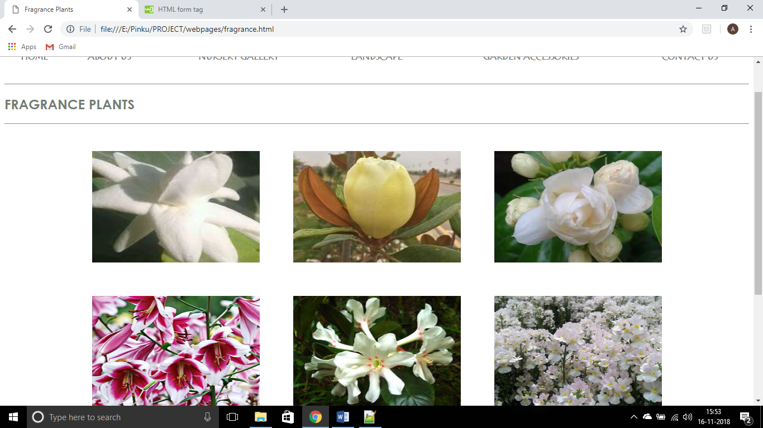

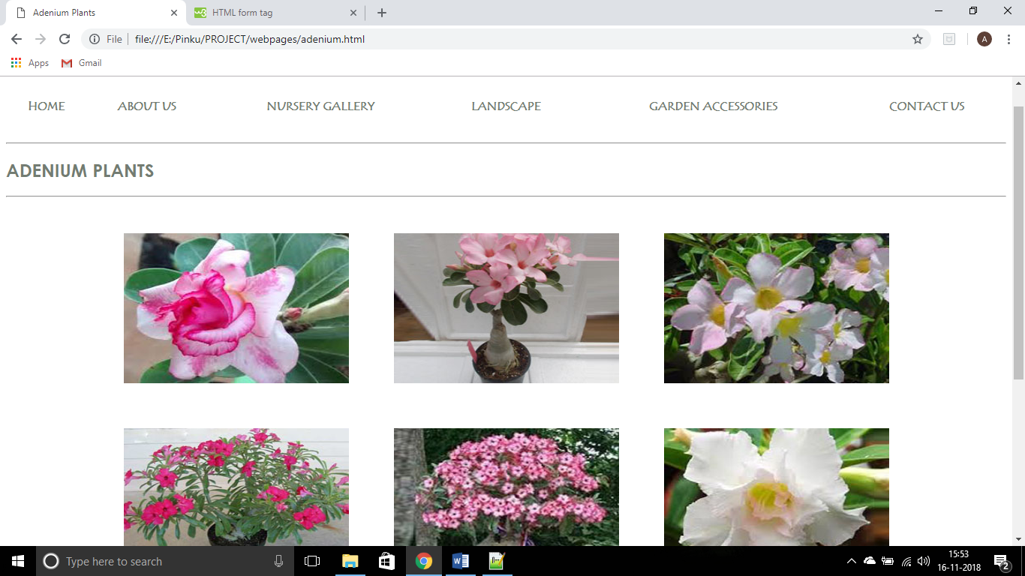

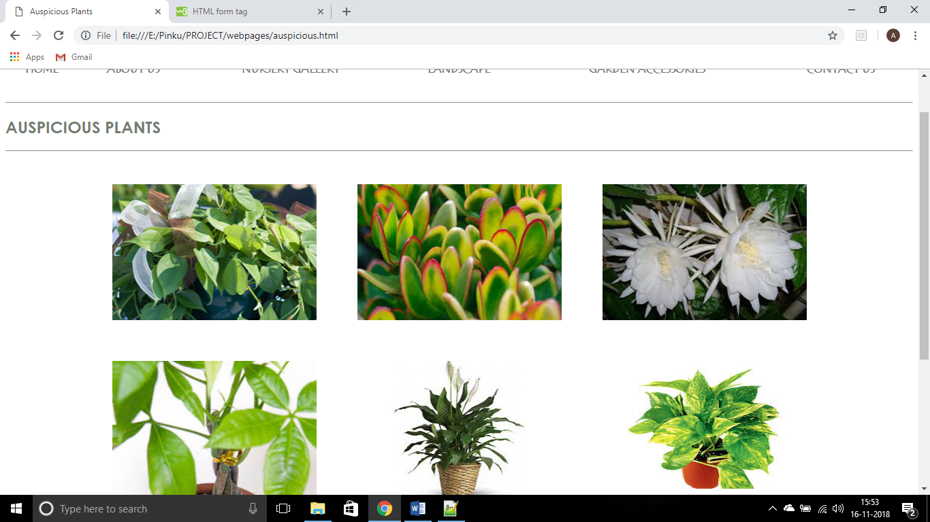

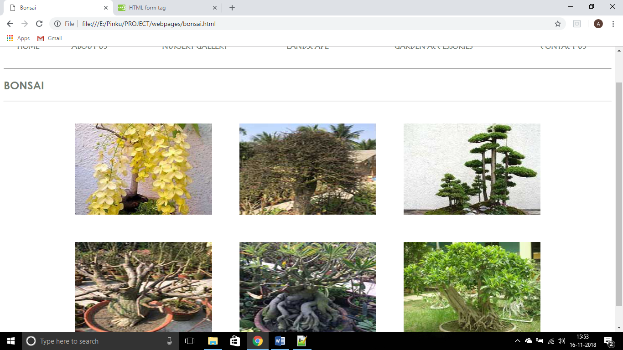

**2.7. Testcases**

Home Page Test

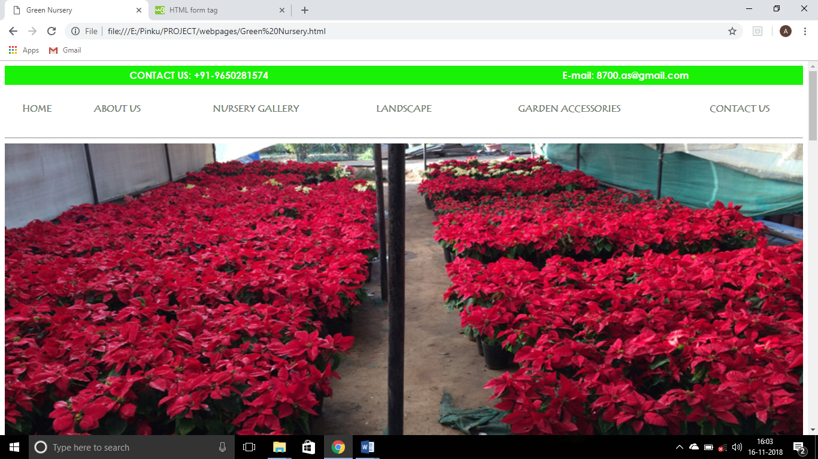

Worked successfully.

About Us Page Test

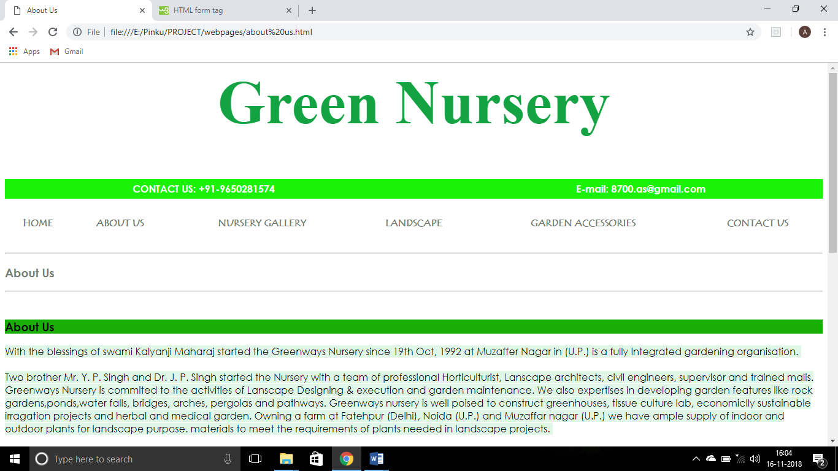

Worked Successfully.

Nursery Galley Page Test

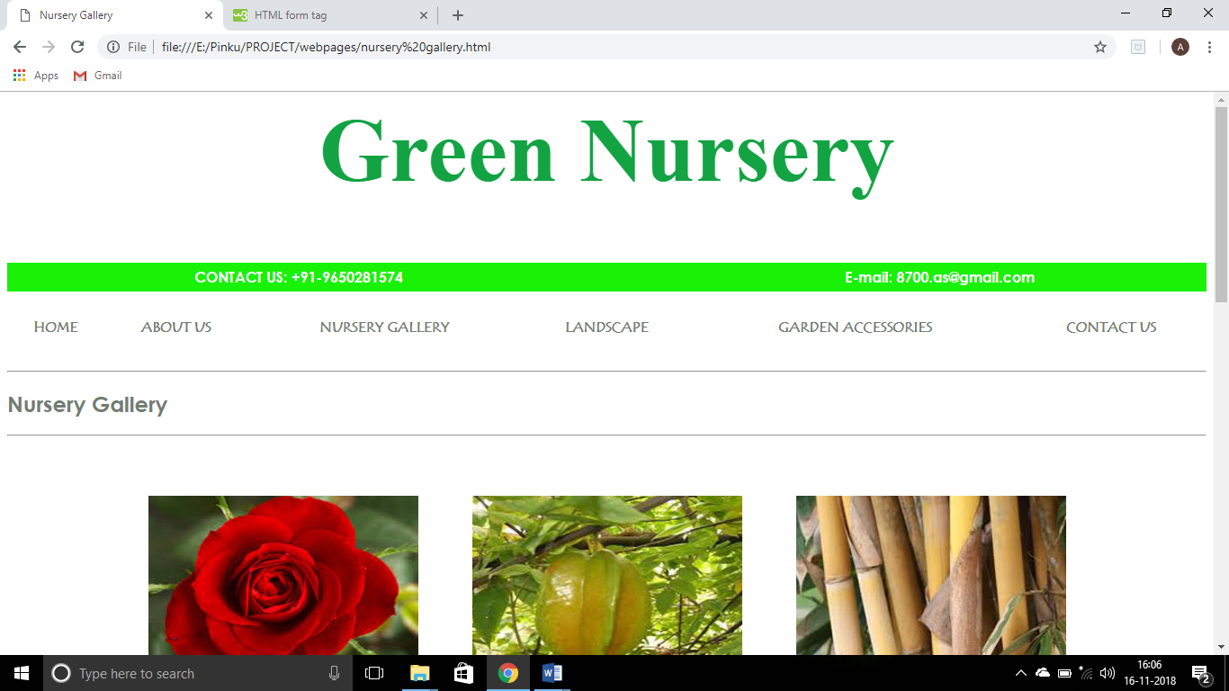

Worked Successfully.

Landscape Page Test

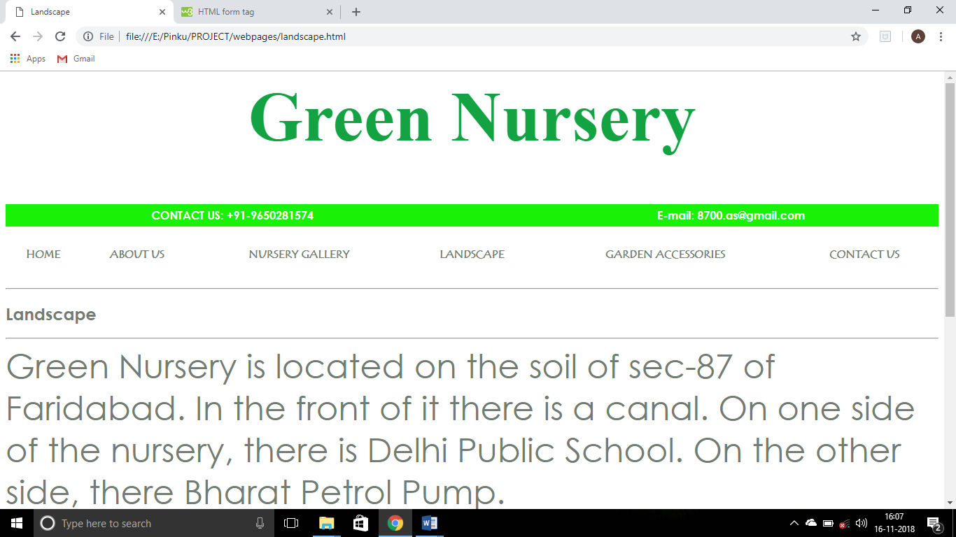

Worked Successfully.

Garden Accessories Page Test

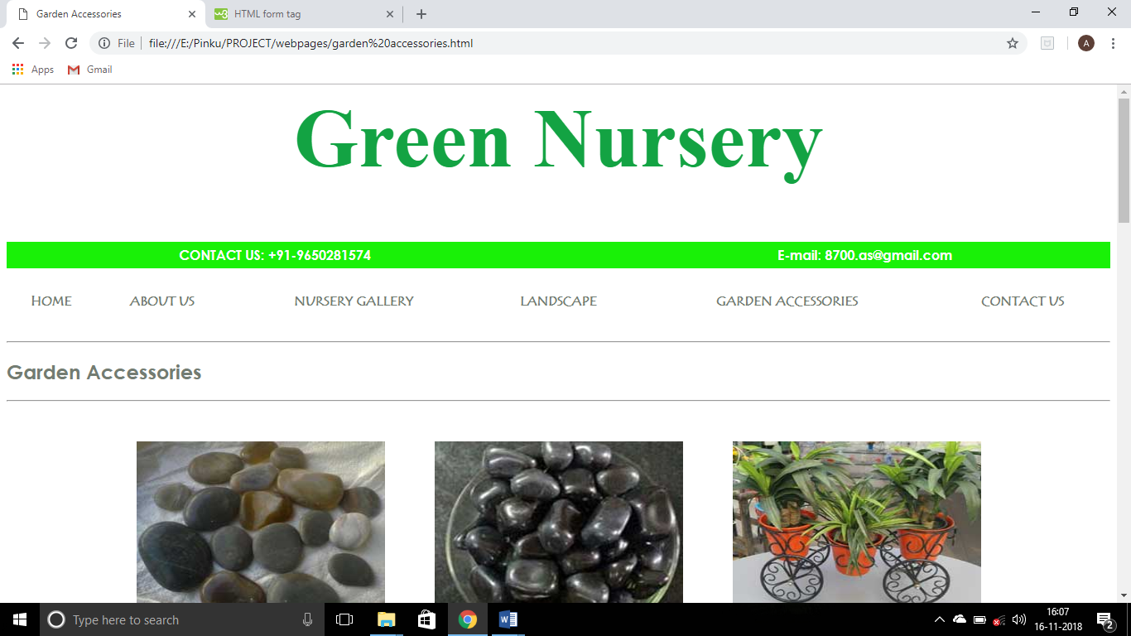

Worked Successfully.

Contact Us Page Test

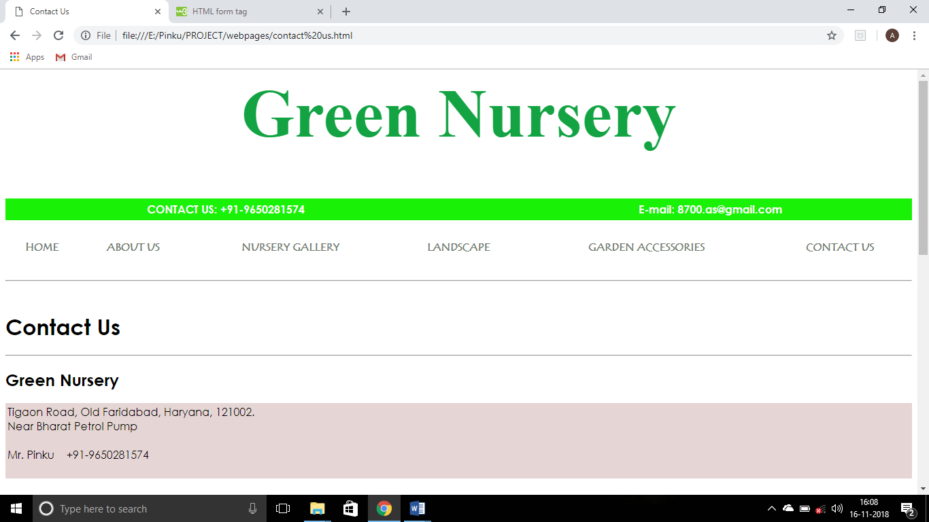

Worked Successfully.

**3. Conclusion**

The Green Nursery Website is developed using HTML and CSS fully meets the objective of system for which it has been developed. The website is operated at a high level of efficiency and all the customers and staff associated with the system understands its advantage. The system solves the problem that it was intended to solve as requirement specification.

1. **SCOPE FOR FUTURE WORK**

There have been cases of computer glitches, errors in content, and security lapses reported in the website. So in the near future the so-called website could be made more secure and reliable. While electronic glitches are rare, they have been known to occur, for instance when computer crashes voided the efforts of staff. This website is not also online i.e. you cannot search for it on the web so the primary target is to launch the website online to be in real use.